**1-3 Assignment: Introduction**

**to MongoDB**

Kevin Rhyden

Southern New Hampshire University

CS-340: Client/Server Development

Jeff H. Sanford

August 20, 2025

Verify access to MongoDB with a username.

Close-up of the top right corner showing my username.

mongoimport --db=enron --collection emails --drop ./datasets/enron.json

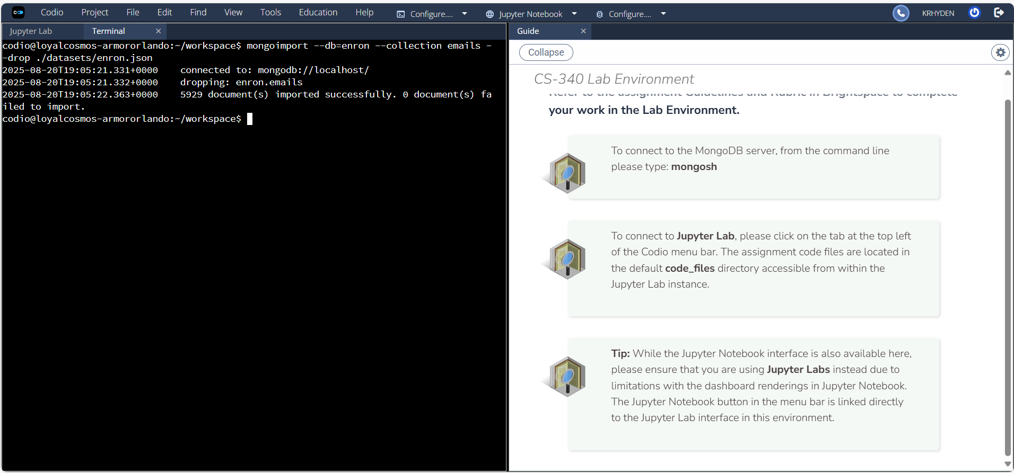

show dbs

use enron

show collections

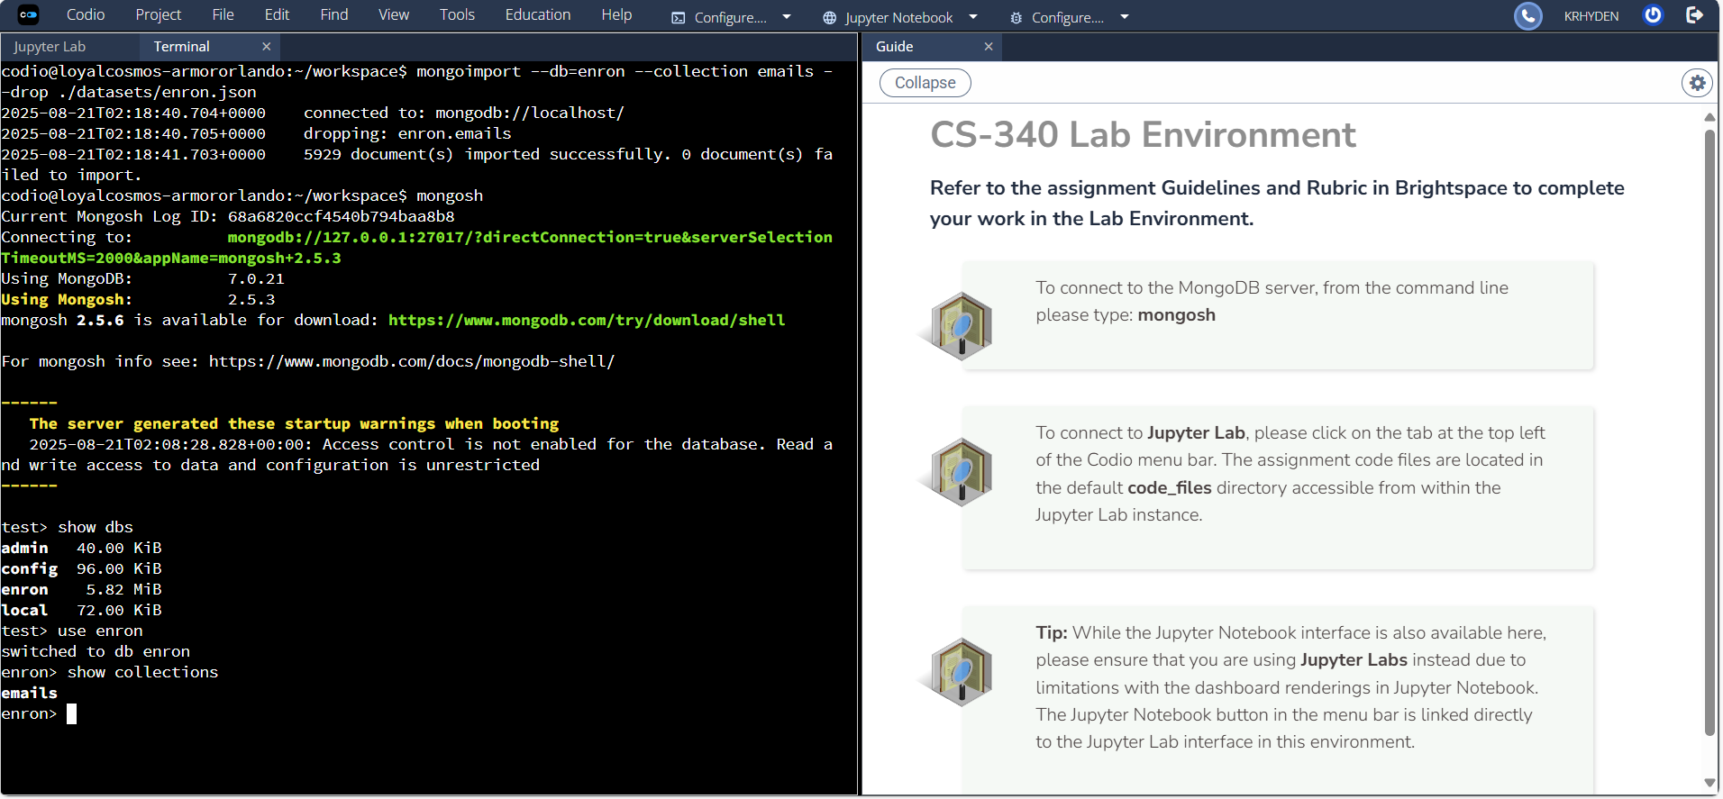

db.emails.findOne()

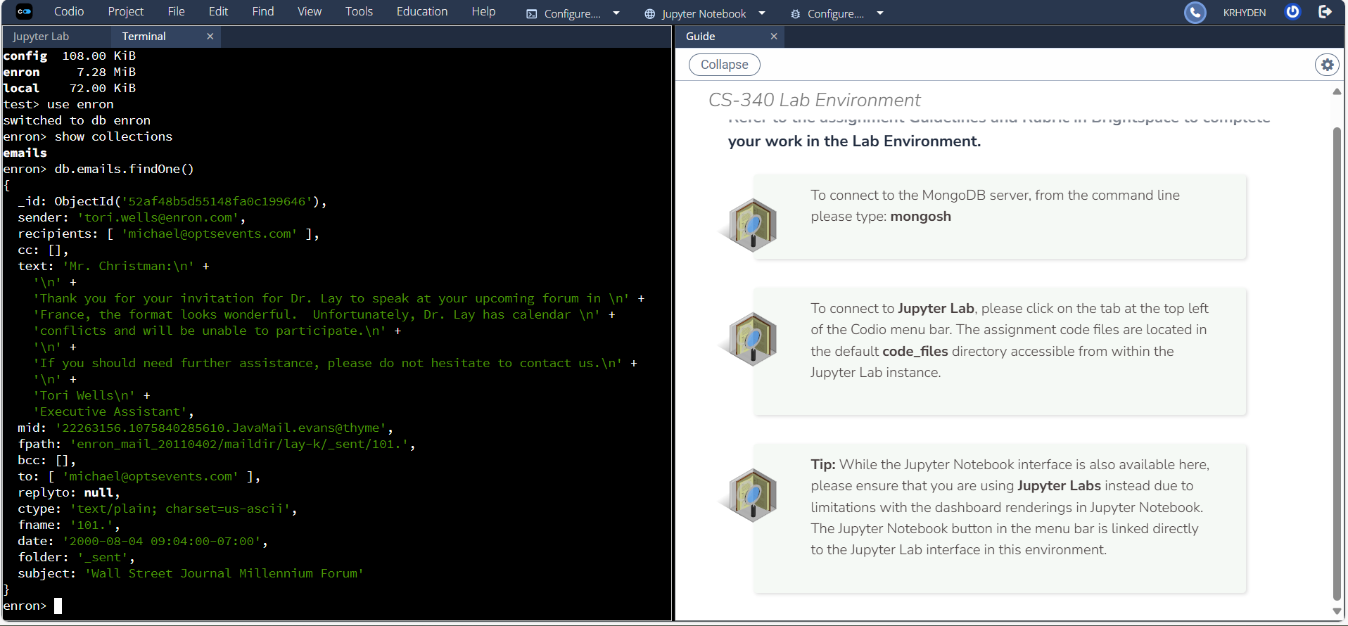

Object.bsonsize(db.emails.findOne({_id:ObjectId('52af48b5d55148fa0c199646')}))

db.emails.totalSize()

